Rest Assured with TestNG

What is Rest Assured :
- REST Assured is a Java library that provides a domain-specific language (DSL) for writing powerful, maintainable tests for RESTful APIs.
- Using Rest Assured we can eliminates large amount of code to test complex API response & output.
- Support both XML & JSON format.

Configuration:
To get started with REST Assured, simply add it as a dependency to your project. If you're using Maven, add the following entry to your pom.xml

<dependency>
<groupId>io.rest-assured</groupId>
<artifactId>rest-assured</artifactId>
<version>3.0.6</version>
</dependency>

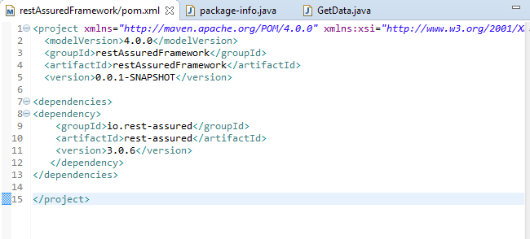

Create a maven Project
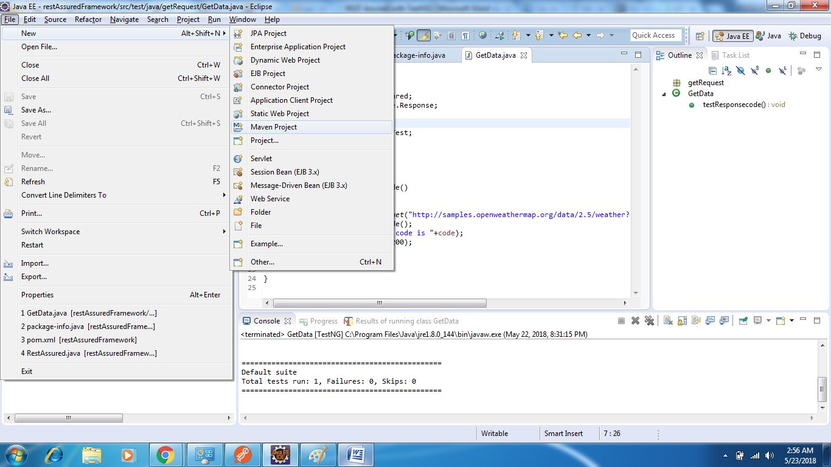

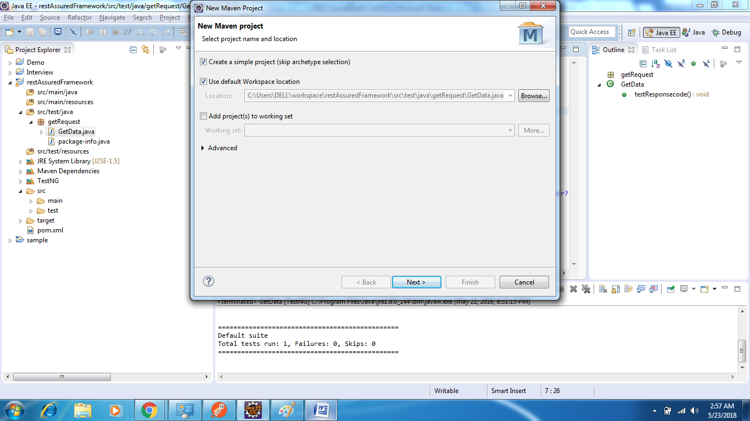

Create a package & Create a class.

package getRequest;

import io.restassured.RestAssured;
import io.restassured.response.Response;

import org.testng.Assert;
import org.testng.annotations.Test;

public class GetData {

@Test
public void testResponsecode()
{

Response resp=RestAssured.get("http://samples.openweathermap.org/data/2.5/weather?q=London,uk&appid=b6907d289e10d714a6e88b30761fae22");
int code =resp.getStatusCode();
System.out.println("Status code is "+code);
Assert.assertEquals(code, 200);
}

}

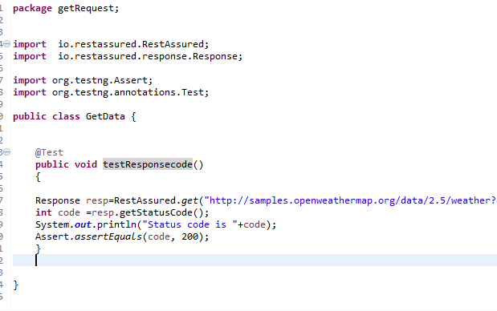

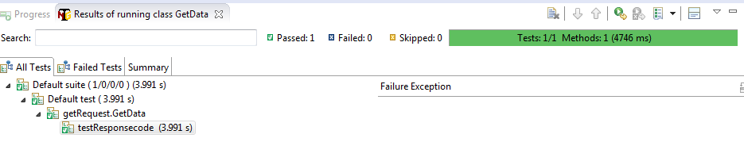

Refrences:

http://www.baeldung.com/rest-assured-tutorial
https://techbeacon.com/how-perform-api-testing-rest-assured

